DIGITAL MARKETING – 6 MONTHS

Month 1 – Foundation & Website Creation
- Introduction to Digital Marketing
- Scope & Career Opportunities
- Digital Marketing Channels Overview
- Case Studies
- Website Planning & Creation
- WordPress / Shopify Setup
- Domain & Hosting
- Landing Page Design
Assignment: Create a personal/business website with blog & contact page.

Month 2 – SEO (Search Engine Optimization)
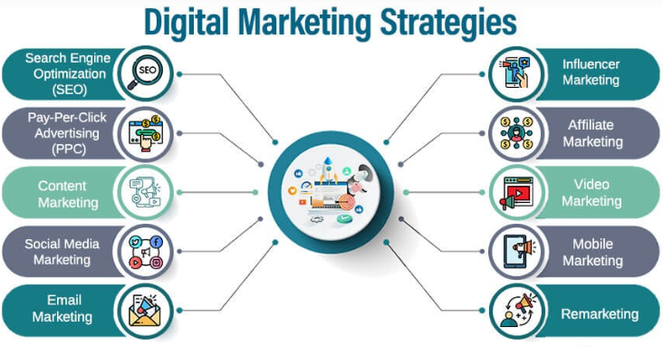
On-Page SEO
- Keyword Research & Tools
- Meta Tags, Headings, URL Structure
- Image SEO, Internal Linking
- : Technical SEO
- Robots.txt, Sitemap, Canonical Tags
- Site Speed, Mobile SEO
- Core Web Vitals
- Off-Page SEO & Local SEO
- Link Building Strategies
- Google Business Profile Setup
- Local SEO Citations

Month 3 – Marketing & Social Media
Google Ads (SEM)
- Search, Display & Video Ads
- Bidding & Targeting Strategies
- Conversion Tracking
- Social Media Marketing (SMM)
- Facebook & Instagram Marketing
- Page/Business Profile Optimization
- Paid Ads (Targeting, Budgeting, Retargeting)
- SMO (Social Media Optimization)
- Hashtag Research
- Engagement Tactics
- Content Scheduling Tools (Buffer, Hootsuite)
Assignment: Run a demo ad campaign on Google / Facebook with a small budget.

Month 4 – Content, Email & Affiliate Marketing
Content Marketing
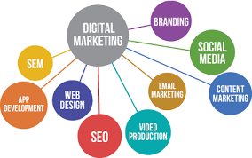
- Blog Writing & SEO
- Video Content Strategy
- Storytelling for Brands
- Email Marketing
- Building Email List
- Mailchimp / ConvertKit Campaigns
- Automation & Analytics
Affiliate Marketing
- Affiliate Networks (Amazon, CJ, ClickBank)
- CPA, CPS Models
- Affiliate Website/Blog Setup
Assignment: Write a blog review with affiliate links.
Month 5 – E-commerce, Video & Advanced Marketing
- E-commerce Marketing
- Shopify / WooCommerce Basics
- Product Listing Optimization
- Google Shopping Ads & Instagram Shops
- Video Marketing & YouTube SEO
- Channel Setup & Optimization
- Video SEO (Titles, Tags, Thumbnails)
- YouTube Ads
- Mobile Marketing & ORM
- WhatsApp Marketing
- App Promotions
- Online Reputation Management
Project: Create a YouTube channel, upload a video, and optimize it for SEO.
Month 6 – Analytics, Automation & Career Prep
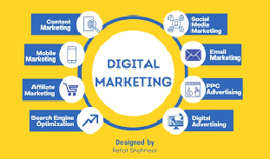
- Web Analytics
- Google Analytics (GA4)
- Google Tag Manager
- Conversion Tracking & Reports
- Marketing Automation & Tools
- CRM Tools (HubSpot, Zoho)
- Chatbots & AI in Marketing
- Zapier & Workflow Automation
- Freelancing & Career Building
- Building Digital Marketing Portfolio
- How to get clients (Upwork, Fiverr, LinkedIn)
- Resume & Interview Prep
Final Project (Capstone):
- Run a complete campaign (SEO + Paid Ads + Social Media) for a live website or client project.
- Present a report with analytics & ROI.



